Itgalpura, Rajanukunte, Bengaluru - 560064

**SOE and SOCSE&IS**

A Project Report on

# “Implementation of Hybrid Power Generation System Using Arduino Controller”

Submitted in partial fulfillment of the requirement for the course

Innovative Projects Arduino using (**ECE2010**)

Submitted by   
 Group: IPA 294

|  |  |
| --- | --- |
| Student Name | Roll No |
| Yash Vinod Naik | 20231CSD0037 |
| Ritin Kumar Gupta | 20231CSD0040 |
| Sathya | 20231CSD0038 |
| Shyam K | `20231ECE0206 |
| Shreya R | 20231CSD0039 |
| Sandeep | 20231CSD0036 |

Under the supervision of

**Guide name:** **Ms.A.Rohini**

**Designation:** **Assistant Professor**

**Department:** **SoCSE**

**Abstract:**

This project focuses on developing an Arduino-controlled solar and wind energy analyzer to monitor renewable energy sources effectively. We created a system that integrates sensors to measure solar irradiance and wind speed. These sensors connect to an Arduino microcontroller, which processes the data and displays it in real-time on an LCD screen.

During development, we stressed the importance of precise sensor calibration for accurate readings. Efficient data handling was crucial to manage sensor information. A key discovery was that optimizing the Arduino code was vital for maintaining system and displaying the output on the LCD screen. By refining the code, we ensured swift and accurate data processing.

Our final model is user-friendly, suitable for educational purposes and practical demonstrations. It highlights the feasibility of using low-cost, open-source hardware to analyze renewable energy (solar and wind energy). This project demonstrates the practical application of Arduino technology in renewable energy and offers insights into integrating sensors and implementing efficient data processing techniques.

Overall, our model showcases the potential of Arduino-based systems in renewable energy monitoring. It displays how affordable technology can enhance understanding of solar and wind energy, promoting greater awareness and knowledge in the renewable energy fiel

**Hardware, Software and tools used:**

Hardware [Components]**-**

The hardware of the Arduino-controlled solar and wind energy analyzer includes LEDs for system status, a rocker SPST switch for on/off control, and a mini breadboard for component connections. Solar panels capture energy, with a mini USB LED bulb demonstrating usage, and a 12V DC motor simulating wind energy. An Arduino IIC I2C LCD display shows real-time data. A two-slot battery holder powers the system, while a voltage controller and regulator ensure stable voltage. Jumper wires connect components, facilitating electricity and data flow throughout the system.

* LED ( 2 pairs)
* Rocker SPST 2 pin switch
* Mini Bread Board
* Solar panels
* Mini USB led bulb
* 12V dc motor
* Arduino IIC I2C LCD display
* 2 slot battery holder / 2 batteries

Software -

The software for the Arduino-controlled solar and wind energy analyzer is developed using the Arduino Integrated Development Environment (IDE). Written in C/C++, it utilizes libraries like LiquidCrystal_I2C for real-time data display on the LCD. The software reads sensor data for solar irradiance and wind speed, processes it to compute energy metrics, and ensures accuracy through calibration routines. System control is managed via digital pins for LEDs and indicators. The code is optimized for efficiency, ensuring responsive data acquisition and display. This integration of hardware and software provides a reliable, user-friendly solution for renewable energy analysis.

Tools Used –

To create an Arduino-controlled solar and wind energy analyzer, several essential tools and steps are involved. Initially, we used the Arduino Integrated Development Environment (IDE) for software development. This platform allows writing, compiling, and uploading C/C++ code to the Arduino microcontroller, leveraging libraries like LiquidCrystal_I2C for displaying real-time data on an LCD screen.

For the hardware setup, key tools included a soldering iron for securing connections, a multimeter for measuring electrical parameters, and a breadboard for prototyping circuits. We used various sensors to measure solar irradiance and wind speed, integrating them with the Arduino for data collection.

Digital design tools such as Tinkercad was employed to create a virtual model of the system. These tools allowed us to simulate the circuit and code, ensuring the design was functional before physical assembly. This step helped identify and resolve potential issues early, saving time and resources.

Once the digital model passed the test run, we proceeded to build the physical model. Components like LEDs, solar panels, a 12V DC motor, and a battery holder were assembled on a mini breadboard. Jumper wires connected the components, while a voltage controller and regulator ensured stable power supply.

By combining these tools and methods, we successfully developed a functional and efficient Arduino-controlled solar and wind energy analyzer, capable of providing accurate and real-time energy data.

**Block diagram & Description:**

Methodology-

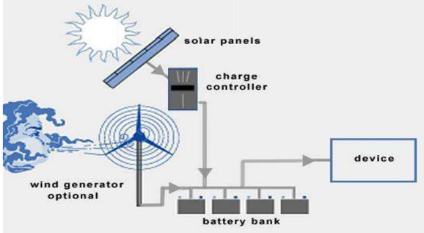

1. **Solar energy:** We used a light sensor to measure sunlight. The brighter it is, the more power the solar panel generates.
2. **Wind energy:** A small windmill connected to a generator creates electricity based on wind speed. The faster it spins, the more power produced.
3. **Measurement:** The Arduino reads the sensor signals (voltage) and converts them to understandable values like watts.
4. **Data Display:** This info can be shown on a simple LCD screen.

By tracking these readings, you can see how much energy your renewable sources are producing throughout the day. This model helps you understand their efficiency and plan your energy use accordingly.

**CIRCUITAL DIAGRAM**

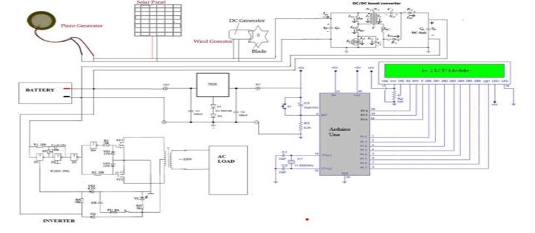

**Circuital Structure**

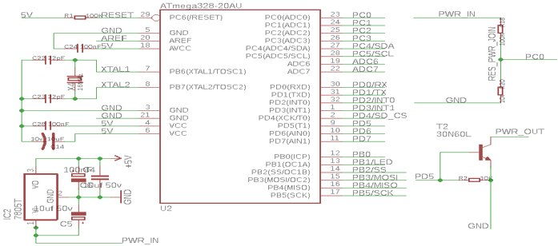

**Architectural Block Diagram**

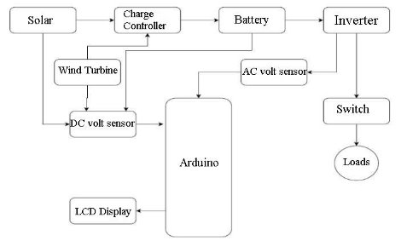

**Description:**

The block diagram illustrates the setup of an Arduino-controlled solar and wind energy analyzer, detailing how various components work together to capture, store, and utilize renewable energy efficiently.

The system starts with two primary sources of renewable energy: solar panels and a wind turbine. Solar panels capture sunlight and convert it into electrical energy. This energy is then sent to a charge controller, which manages the flow of electricity to the battery. The charge controller ensures that the battery is charged safely and prevents overcharging, which can damage the battery.

Simultaneously, the wind turbine generates electricity from wind energy. The output from the wind turbine is fed into a DC voltage sensor, which measures the voltage produced. This sensor data is crucial as it allows for monitoring the performance of the wind energy system.

Both the charge controller and the DC voltage sensor send their data to the Arduino microcontroller, which acts as the central processing unit of the system. The Arduino collects and processes this data to provide insights into the efficiency and performance of the solar and wind energy systems. This real-time monitoring is crucial for understanding how well the systems are functioning.

The battery, which stores the energy generated by the solar panels and wind turbine, serves as a power reservoir. The stored energy is in the form of direct current (DC). However, most household appliances run on alternating current (AC). Therefore, the system includes an inverter that converts DC from the battery into AC. This conversion is necessary to make the stored energy usable for household loads.

To ensure the proper functioning of the inverter and to monitor the energy being used, an AC voltage sensor is placed between the battery and the inverter. This sensor provides real-time voltage data to the Arduino, enabling it to monitor the system's performance continuously.

The inverter's output is then connected to a switch, which controls the flow of electricity to various loads (appliances and devices). This switch can be used to manage which devices are powered by the system at any given time.

Finally, the Arduino is connected to an LCD display. This display provides users with real-time information about the system, including data on energy generation, storage, and usage. By viewing this information, users can gain valuable insights into the performance of their solar and wind energy systems.

This block diagram and circuit connection represent a well-organized approach to integrating solar and wind energy systems using Arduino technology. The setup ensures efficient energy capture, storage, and utilization, providing a reliable and user-friendly means of monitoring and managing renewable energy sources.

**Results (Model’s image):**

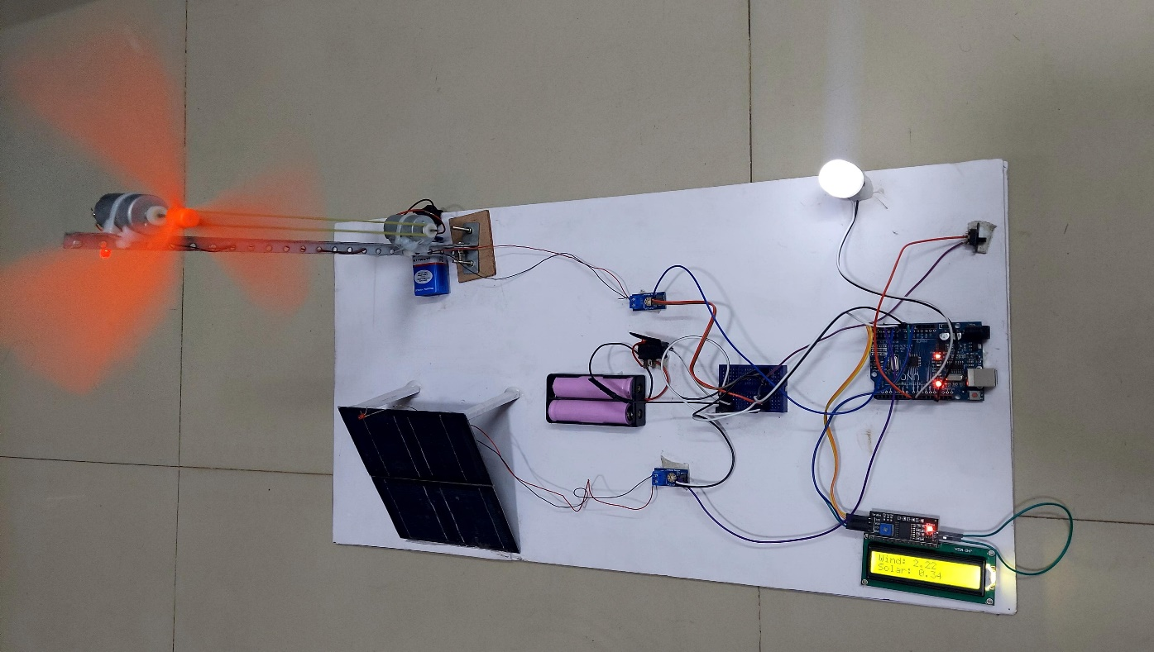

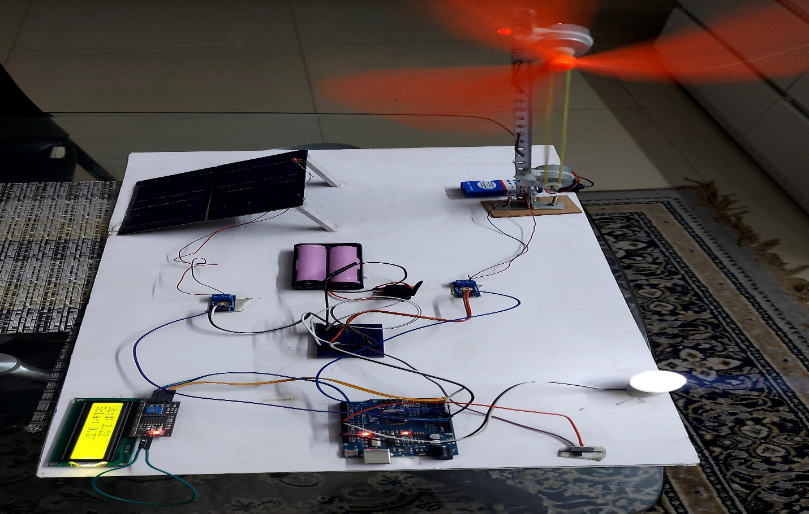

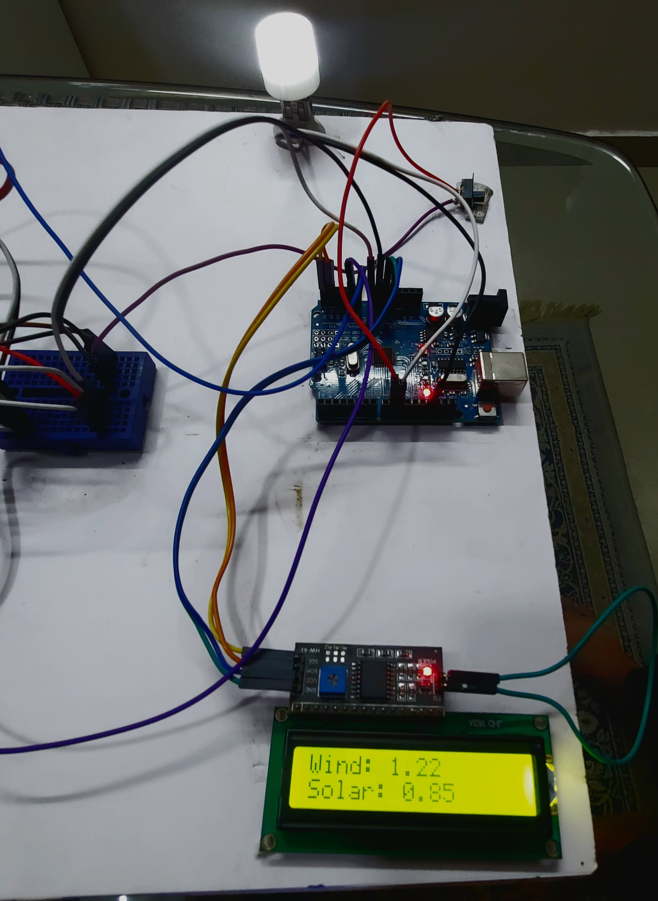

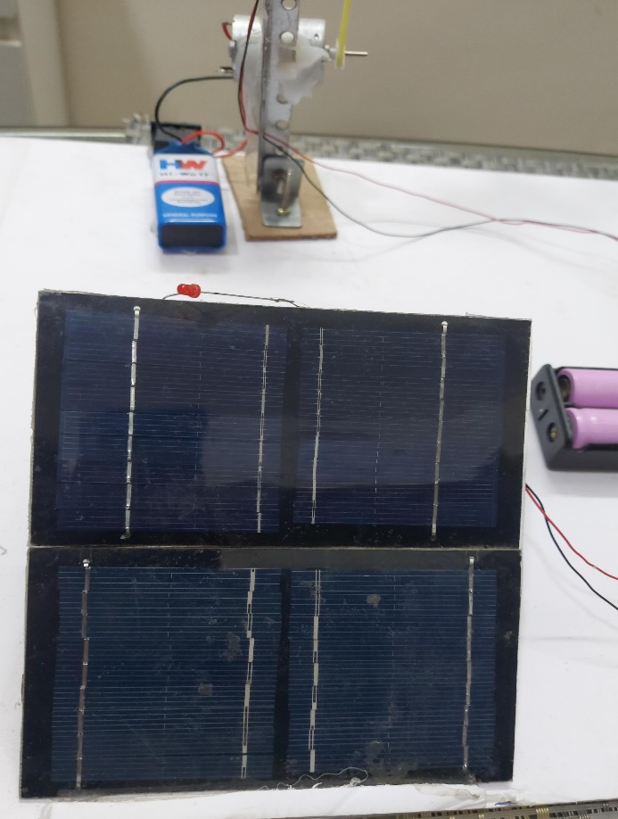

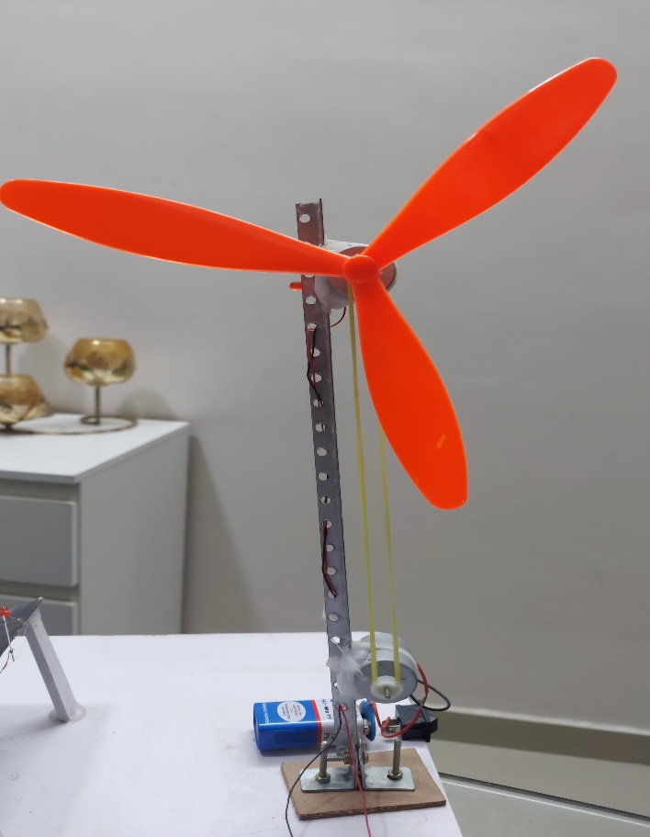

**Challenges faced:**

• **Preparations:** Sourcing all necessary components and ensuring compatibility was challenging, as different sensors and modules needed to work seamlessly with the Arduino.

• **Planning Structure:** Designing a comprehensive and efficient framework for integrating solar and wind systems required careful consideration of component placement and system layout.

• **Building:** Assembling the hardware was complex, involving precise placement of solar panels, wind turbines, and other components to ensure optimal energy capture and flow.

• **Soldering:** Achieving clean and reliable solder joints was critical but challenging, particularly when working with delicate components and ensuring strong electrical connections.

• **Circuit Connection:** Designing and testing the circuit connections to avoid short circuits and ensure stable power supply to all components required meticulous attention to detail.

• **Sensor Calibration:** Ensuring the accuracy of the sensors for solar irradiance and wind speed involved repeated calibration and validation against known standards.

• **Coding:** Writing efficient and error-free Arduino code to handle data acquisition, processing, and display was time-consuming, especially for real-time monitoring and responsiveness.

**Conclusion:**

In conclusion, the development of the Arduino-controlled solar and wind energy analyzer has demonstrated the viability and effectiveness of using low-cost, open-source hardware for renewable energy monitoring. Through careful planning, meticulous assembly, and strategic coding, we created a system that reliably captures, processes, and displays real-time data on solar and wind energy production. This project not only highlights the practical applications of Arduino technology in the renewable energy sector but also underscores the importance of integrating multiple energy sources for a more comprehensive and resilient energy solution.

The process involved overcoming numerous challenges, from the initial preparations and planning structure to the technical intricacies of building, soldering, and circuit connections. Ensuring accurate sensor calibration and efficient data handling were critical to the system’s success, as was the development of robust and responsive Arduino code. Each stage of the project required careful attention to detail and iterative problem-solving, ultimately leading to a functional and user-friendly energy analyzer.

Our final model provides valuable educational insights, demonstrating how renewable energy systems can be monitored and managed effectively. It offers a tangible example of how technology can be harnessed to address the growing need for sustainable energy solutions. By utilizing both solar and wind energy sources, the analyzer showcases the potential for hybrid systems to provide more consistent and reliable power.

Overall, this project serves as a testament to the capabilities of Arduino-based systems in advancing renewable energy technologies. It paves the way for further innovations and encourages the adoption of sustainable practices. The knowledge gained from this project will undoubtedly contribute to future endeavors in renewable energy monitoring and management, promoting greater awareness and utilization of eco-friendly energy sources.